kg
1 kilogram = ? gram
1 ton = ? kg

kg
1 kilogram = 1000 gram
1 ton = 1000 kg

hg
1 hectogram = ? gram
1 ons = ? gram

hg
1 hectogram = 100 gram
1 ons = 100 gram

dag
1 decagram = ? gram

dag
1 decagram = 10 gram

g
? gram

g
1 gram

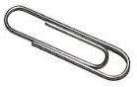

dg
10 decigram = ? gram

dg
10 decigram = 1 gram

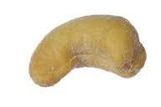

cg
100 centigram = ? gram

cg
100 centigram = 1 gram

mg
1000 milligram = ? gram

mg
1000 milligram = 1 gram

